Insert Title Paper Here <Article title: 12 pt Times New Roman bold; black>

Author full name, Qualifications, Department
Author full name, Qualifications, Department
Author full name, Qualifications, Department
*Corresponding Author full name, Qualifications
Department, Institution

<Insert Cover Page: “Insert Cover Page”>

Abstract
This is the abstract text in a single paragraph. Please key-in here and limit the abstract within 200 words. Use paper text style <12 pt Times New Roman, bold>. This should cover the objectives and conclusions of your submission and explain its relevance to the journal where the paper is being submitted. It should not include references, abbreviations or mentions of figures.
KEYWORDS: please include 3+ keywords, separated by “,”
Introduction
<Body Text: 12 pt Times New Roman, double spaced, justified text> In Mundus Salus Organizatio cancer praedicat terrarum rates duplices profecti sunt ab 2020.¹ <citation style based on the discipline standard, i.e. MLA, Nature, etc.> X decies novum cancer est diagnosed per annum worldwide, omnino operari necesse est ut efficax ne expeditionem. A current modum esse solebat alloqui discrimine non cancer cancer immunotherapy, quem profectum ad progressionem cancer treatments exponentialium feliciter duxit. In reference to Z-score equation in Equation (1).
$Z= \frac{(x-μ)}{σ}$ (1)
<Equation: 11 pt. Insert Equation, Times New Roman, centered>

A current modum esse solebat alloqui discrimine non cancer cancer immunotherapy, quem profectum ad progressionem cancer treatments feliciter duxit exponentialium, as shown in Table 1.
Table 1. Table Description or Title <Tables: 11 pt, Times New Roman>
Time (s)
Distance (m)
Displacement (m)
*Note: A current method <Table Footnotes: 9 pt Times New Roman>

Distantia corporum dependent ab emitti industria translationis processus metitur donatorem accipiens excitat.Refer to Figure 1.
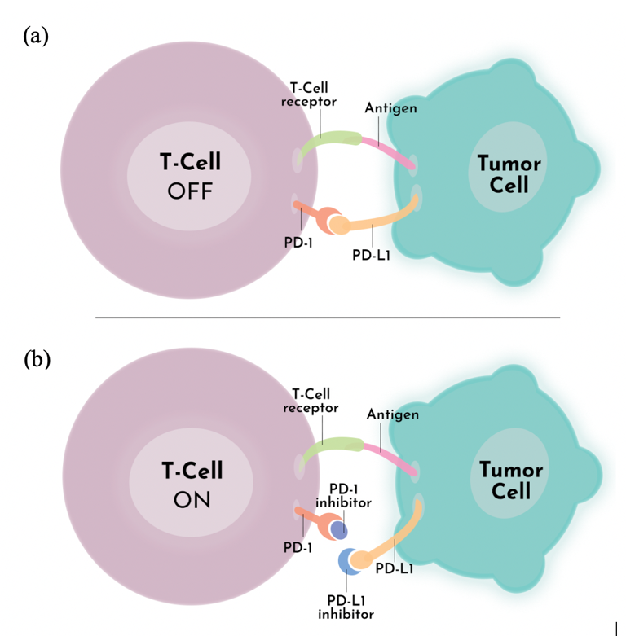
Figure 1. Figure 1 caption. <Tables: 11 pt, Times New Roman> PD-1/PD-L1 Pathway Mechanism of Action (a) Tumor Uses PD-L1 as Defense Mechanism. (b) PD-1/PD-L1 Inhibitor Blocks Tumor’s Defense Mechanism

Conclusion
Distantia corporum dependent ab emitti industria translationis processus metitur donatorem accipiens excitat.
Acknowledgements
<12 pt Times New Roman. Include acknowledgement to those who have contributed to the work and relevant funding agencies>
Reference
<12 pt Times New Roman. Follow the citation format that is standard for your discipline. Refer to you graduate student mentor and/or your research professor>

