Article Title (12 pt Times New Roman bold)

Author full name, Major
Author full name, Major
Faculty Mentor, Department

Abstract
Abstract should be a single-spaced paragraph in bold 12 pt. Times New Roman font. The word limit is 200 words. The abstract should cover the objectives and conclusions of your submission and explain its relevance to its field. It should not include references, abbreviations or figures.
KEYWORDS: please include 3+ keywords, separated by commas
Introduction
The body of the article should be in 12 pt. Times New Roman. Text should be double-spaced. The citation style should be what is normal in your field (MLA, APA, ASE, etc.).
Headings: Headings should be bold, 12 pt. Times New Roman font.
Equations: 11 pt. Times New Roman, centered
$Z= \frac{(x-μ)}{σ}$ (1)

Tables: Tables should be in 11 pt. Times New Roman font.

Table 1. Table Title
Time (s)
Distance (m)
Displacement (m)
Figures
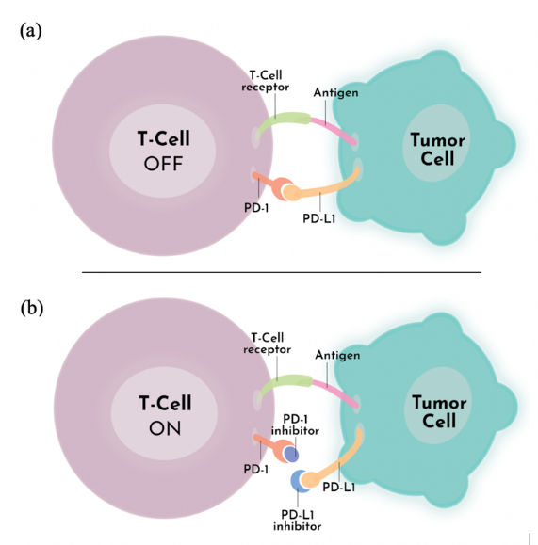
Figure 1. Figure captions should be 11 pt, Times New Roman

Acknowledgements
12 pt. Times New Roman. Acknowledgments should recognize everyone who has contributed to the work and include relevant funding agencies.
References
12 pt. Times New Roman. Follow the citation format that is standard for your discipline.

